The potential migration options are:
1. Renumber all private IPv4 addressing to be compatible;
2. Implement a proxy service at the ingress/egress of each private network;
3. Leave the private IPv4 interface unchanged and implement a new IPv6 interface (dualstack)
on end-systems or
4. Leave the private IPv4 interface unchanged and implement double Network Address
Translation (NAT).
Of these options, the first was considered un-realistic. The second can be unscalable for
ingress flows and imposes topology restrictions. The third may involve applications on legacy
systems that cannot migrate to a dual stack IPv4/IPv6 environment. As a result, the XXXX
architecture is based on the fourth option of double-NAT by implementing NAT-PT. This does not prevent the deployment of the third option where feasible. ………

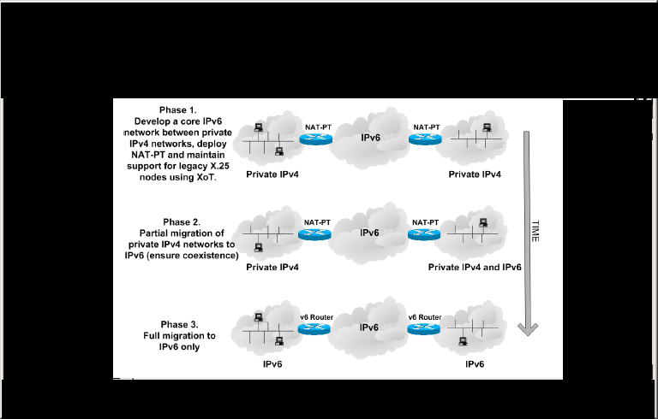

Below are some comments on the referred proposal to deprecate NAT-PT.

Currently, NAT-PT is this only tool to allow IPv4 (only) and IPv6 (only) end-systems communicate with each other without implementing dual-stacks. This proposal does not include any alternative mechanism. For me the authors do not recognise the need for NAT-PT for the transitional period to allow an IPv4 (only) host communicate with an IPv6 (only) host.

Dual stacking end-systems is not always possible, for example we operate a series of OS's which only support IPv4. Over time these will be upgraded but we need a solution for the interim.

Issue of embedded addresses (2.1): We do not expect NAT-PT to resolve all interoperability concerns with ALGs

Issue of binding decay (2.4): Agree that this is possible. For critical client/server applications we work on the basis of static translations as opposed to dynamic. We could envision a proxy service with one IP address for scalability purposes.

Single-point of failure (3.2) : Agree this feature is lacking. Our current solution is to have two independent routers with the same static translations working with different routing metrics. It would be nice to have HSRPv6 and context management for the dynamic NAT-PT translations.

